***Evaluation Reports***

|  |  |
| --- | --- |
| ***NAME*** | Sarthak Rathore |
| ***EMAIL ADDRESS*** | sarthakrathore38@gmail.com |
| ***PHONE NO.*** | 9579071254 |
| ***DEPARTMENT*** | Social Media Marketing |
| ***HR NAME*** | Minisha George |
| ***JOINING DATE*** | 06/09/2001 |

***MENTION YOUR ACTIVITIES THROUGHOUT MONTH:***

* FIRST WEEK ACTIVITIES:

1. Task No.:1(Poster Making)
2. Screenshots of the task:



Suggestions: -

Complaints: -

* TWO WEEK ACTIVITIES

1.Task No.: 2

2.Screenshots of the task: 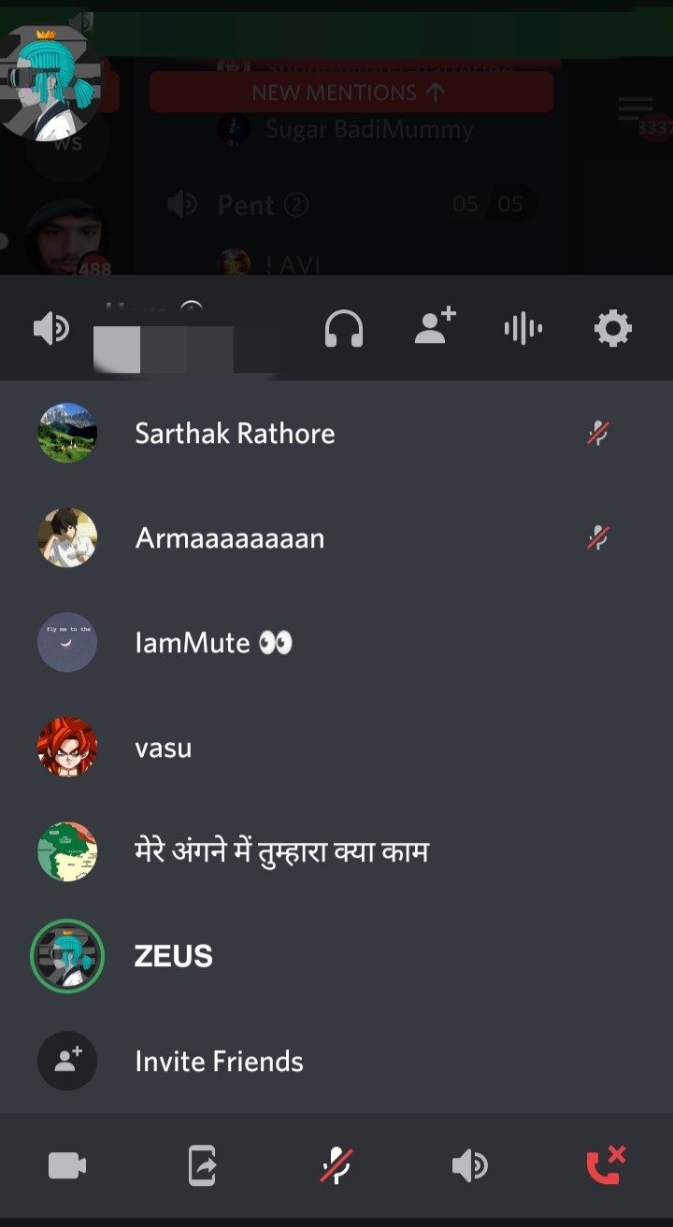

Suggestions:-

Complaints:-

* THREE WEEK ACTIVITIES

1.Task No.: 3

2.Screenshots of the task: <https://milaap.org/fundraisers/support-SarthakRathore>

Suggestions:-

Complaints:-

* FOUR WEEK ACTIVITIES

1.Task No.:

2.Screenshots of the task:

Suggestions:

Complaints:

* FIFTH WEEK{IF APPLICABLE}